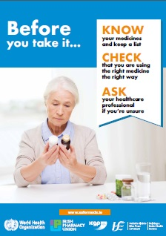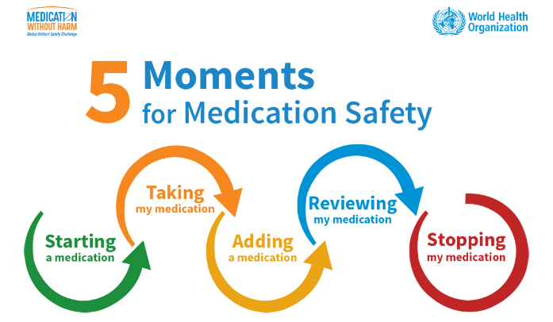

If you are fasting on the day of admission please take your regular medications with a sip of water UNLESS you have been told by your Consultant to HOLD them

What is My Medicines List?

My Medicines List is a list of all the medicines and supplements you take.

Why should I use it?

Keeping an up-to-date list can help you know your medicines. It can also help you when discussing your medicines with a healthcare professional and can reduce the risk of any prescription errors.

How should I fill it in?

To fill out My Medicines List, you need all your medicines in front of you. Another option is to ask your pharmacist to print out a list for you. Make sure you include all prescribed and over-the-counter medicines and supplements.

How should I use it?
Keep your list up to date. Bring it with you when attending any healthcare appointment.
You may find it useful to keep a photo of this list on your phone.

How can I get another form?

To get a copy ask the ward you attend or you can print a version of this list

PLEASE BRING YOUR OWN MEDICATIONS, IN THEIR ORIGINAL PACKAGING INTO HOSPITAL

PLEASE BRING YOUR OWN MEDICATIONS (IN THEIR ORIGINAL PACKAGING) WITH YOU ON ADMISSION
My Medicines
My allergies and how I react:

Name of medicine or supplement | Strength | How much I take each time | I take it | I take it every day (Yes / No) | Why I take it? | My notes
Example: ABC Tablets | 25mg | 2 tablets | Once in the morning | Yes | For my heart | Take with food
Name |  | Date of birth |  | Date I filled  out this form

